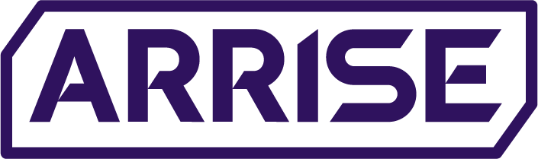

Arrise Live Quality Policy

Version | Date (YYYY-MM-DD) | Change | Author(s) - name &role | Approvers – name & role
1.00 | 2025-01-09 | First Version | Anca-Diana Boros  Director of QC & Training | Vijay K Rajan  Senior VP of Operations
1.1 | 2025-04-17 | Updated to incorporate feedback received from the External Auditor | Laura Marin  LC Process Manager | Vijay K Rajan  Senior VP of Operations
1.2 | 2025-07-22 | Template Update | Laura Marin  LC Process Manager | Vijay K Rajan  Senior VP of Operations
1.3 | 2026-01-16 | Annual Review | Laura Marin  LC Process Manager | Vijay K Rajan  Senior VP of Operations

Contents
Our Commitments 2
Quality Objectives 2
Implementation and review 3
Responsibility 3

Quality Policy for Arrise Live

This Quality Policy covers all aspects related to the Production Line and Support Departments, ensuring adherence to established standards and continuous improvement in quality management.

Our Commitments

- Quality Management System
We are committed to driving the effectiveness of our system by fostering a process-oriented, risk-based culture, ensuring quality management and compliance, engaging our people, and pursuing continuous improvement.

- Customer Focus
We prioritize understanding and meeting the needs of our customers by offering engaging, fair, and reliable experiences. Customer satisfaction is at the heart of our operations, driving improvements to our platform and services, brought to Operation department’s attention by partner departments of The Company.

- Legal and Regulatory Compliance
We ensure that all services provided adhere to relevant laws, industry regulations, and ethical standards. Partner Departments of the Company monitor regulatory changes to maintain compliance and ensure our services achieve regulatory compliance.

- Operational Efficiency
We prioritize efficiency and reliability in the delivery of our services. Our systems and processes are designed to minimize errors, reduce downtime, and identify improvement opportunities.

- Continuous Improvement
We are committed to improve the quality of our services through regular performance evaluations, internal customer feedback analysis, and consistency across all processes. Improvement initiatives are systematically integrated into our operations to exceed quality standards.

- Employee Development
Our team is our most valuable asset. We invest in employee training and professional development to equip our staff with the skills and knowledge necessary to deliver exceptional service and achieve quality objectives. We support other relevant management roles to demonstrate the application of leadership within their areas of responsibility.

Quality Objectives

To deliver our commitments, we have established clear quality objectives, including:
- Maintain industry certifications (e.g., ISO 9001 for QMS) to guarantee trust and transparency to our customers and employees.
- Achieve and maintain high quality results by continuous monitoring of employee’s performance.
- Offer high quality services by continuously tailoring training programs for both new & experienced employees.
- Provide an exclusive, high-quality experience for clients.
- Maintain the contracted uptime for our platform, ensuring uninterrupted service to operators through planned downtime services.
- Develop a highly engaging and customizable experience tailored to the needs of external operators.
- Ensure a seamless multi-device experience (desktop, mobile, tablet) with responsive design and native app support.
- Ensure all services meet or exceed regulatory requirements.
- Enhance operational efficiency and reduce errors through process optimization.

Implementation and review
- This policy is communicated to all employees and stakeholders to ensure alignment with our quality standards and objectives.
- Our Quality Management System (QMS) is implemented in line with ISO 9001:2015 requirements and annually audited for compliance and effectiveness.
- The Quality Policy is reviewed periodically by the senior VP of Operations to ensure its ongoing relevance and alignment with organizational goals.

Responsibility
The Top Management, through its executive leadership structure, is committed to providing the necessary resources to achieve the quality objectives and ensuring that all employees are engaged in the pursuit of quality standards. All employees and stakeholders are responsible to contribute to the effective implementation of this policy.

